*Effects of winter conditions on Olympia oyster reproduction and larval yield*

**Authors:** Laura H Spencer1, Erin Horkan2, Ryan Crim2, Steven B Roberts1

1University of Washington, School of Aquatic and Fishery Sciences, 1122 NE Boat St, Seattle, WA 98105, United States

2Puget Sound Restoration Fund, 8001 NE Day Rd W, Bainbridge Island, WA 98110, United States

### Supplemental Materials

**Supplemental Figure 1:** Gonad sex, male gamete stage, and female gamete stage over time by treatment. Broodstock were in treatments during weeks 0-13, and were in common conditions to induce spawning (high food and high temperature) on weeks 15 and 16.

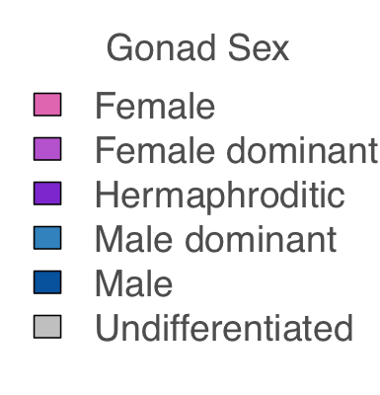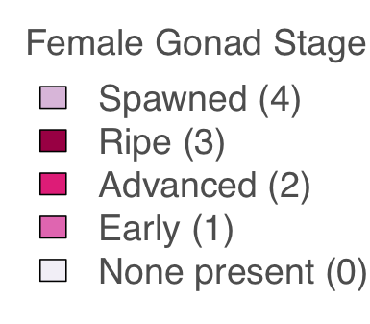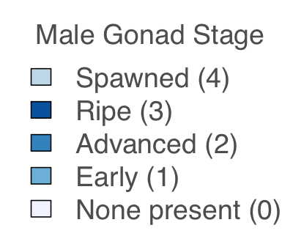

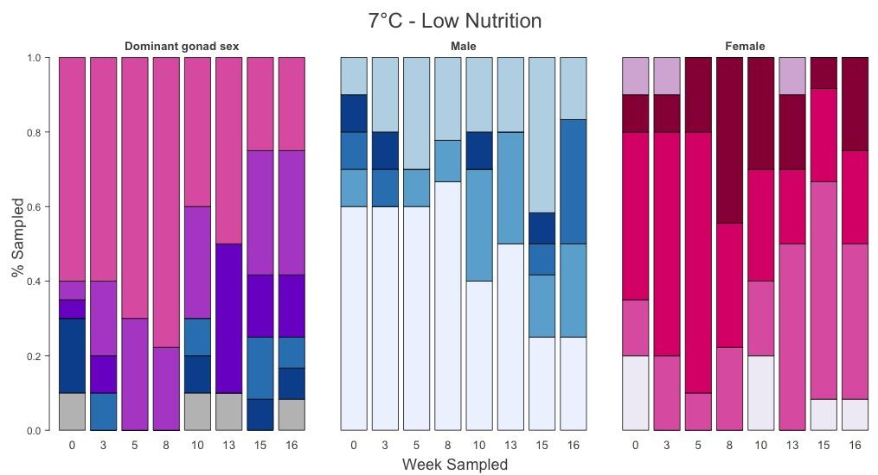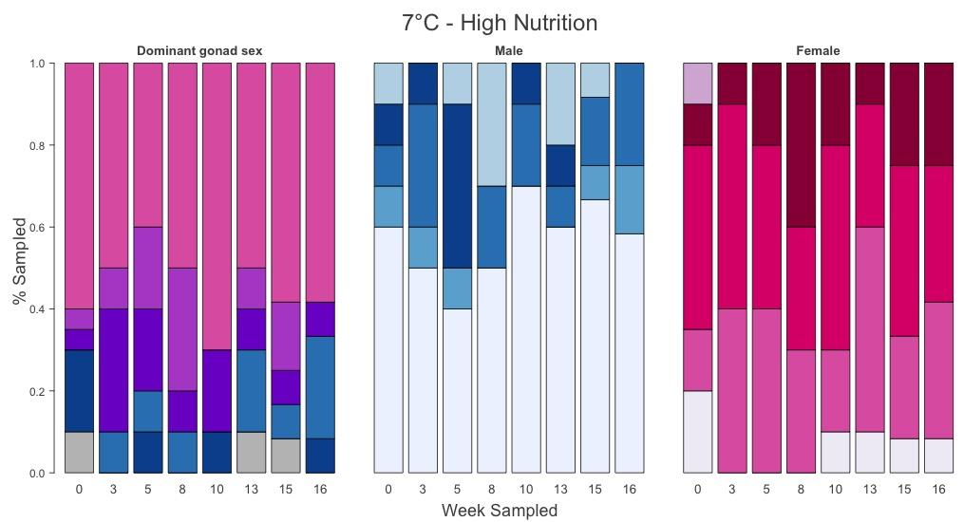

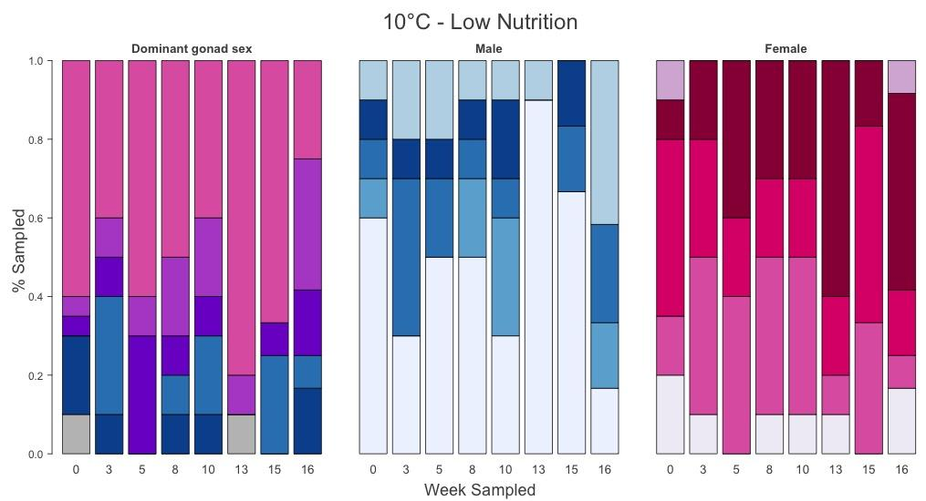

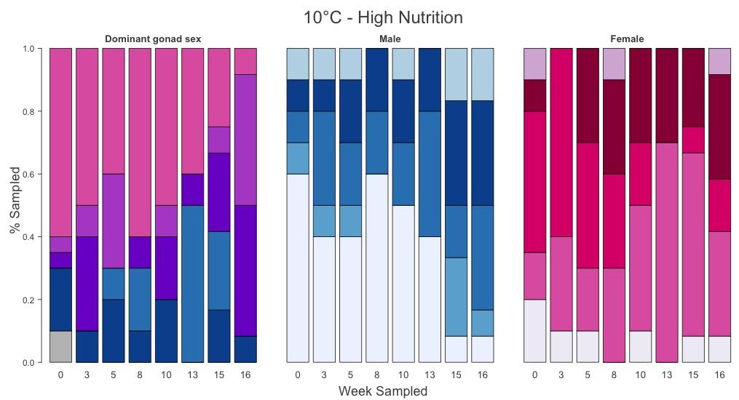**Supplemental Table 1:** Male gonad stage at week 13 differed by treatment (final sample date prior to reproductive conditioning), 𝝌2 = 32.5, p=0.0052.

|  |  |  |  |  |  |
| --- | --- | --- | --- | --- | --- |
| Male stage, week 13 only | None present (0) | Early (1) | Advanced (2) | Ripe (3) | Spawned (4) |
| 7C / LOW FOOD (A) | 5 | 3 | 0 | 0 | 2 |
| 7C / HIGH FOOD (C) | 6 | 0 | 1 | 1 | 2 |
| 10C / LOW FOOD (B) | 9 | 0 | 0 | 0 | 1 |
| 10C / HIGH FOOD (D) | 4 | 0 | 4 | 2 | 0 |

**Supplemental Table 2:** Male gonad stage during reproductive conditioning (weeks 15 & 16 combined) differed by treatment, 𝝌2 = 32.2, p=0.0010

|  |  |  |  |  |  |
| --- | --- | --- | --- | --- | --- |
| Male stage, weeks 15 & 16 | None present (0) | Early (1) | Advanced (2) | Ripe (3) | Spawned (4) |
| 7C / LOW FOOD (A) | 5 | 5 | 4 | 1 | 7 |
| 7C / HIGH FOOD (C) | 15 | 3 | 5 | 0 | 1 |
| 10C / LOW FOOD (B) | 10 | 2 | 5 | 2 | 5 |
| 10C / HIGH FOOD (D) | 2 | 4 | 6 | 8 | 4 |

**Supplemental Table 3:** Larval collection data by broodstock winter treatment (4 replicate spawning tanks per treatment).

|  |  |  |  |  |
| --- | --- | --- | --- | --- |
|  | 7C - Low Nutr. | 7C - High Nut. | 10C - Low Nutr. | 10C - High Nutr. |
| Mean larvae collected / day | 424,000  365,000  140,000  357,000  = 339,000 (overall) | 219,000  349,000  448,000  269,000  = 312,000 (overall) | 364,000  299,000  381,000  197,000  = 304,000 (overall) | 395,000  261,000  280,000  295,000  = 304,000 (overall) |
| Median larvae collected/day | 168,000  382,000  135,000  229,000  = 212,000 (overall) | 186,000  457,000  256,000  262,000  = 256,000 (overall) | 210,000  281,000  419,000  186,000  = 218,000 (overall) | 319,000  125,000  164,000  184,000  = 195,000 (overall) |
| Max collected | 2,073,000  1,274,000  698,000  248,000 | 1,116,000  610,000  567,000  426,000 | 1,238,000  915,000  871,000  561,000 | 1,190,000  962,000  918,000  677,000 |
| Total larvae released | 5,939,000  3,652,000  1,116,000  2,854,000  = 13,561,000 | 1,756,000  1,743,000  3,133,000  2,421,000  = 9,053,000 | 4,729,000  3,583,000  3,427,000  2,561,000  = 14,300,000 | 3,558,000  2,606,000  3,361,000  3,831,000  = 13,357,000 |
| No. of Broodstock  (at end of collection) | 32, 31. 28, 34  = 125 (sum) | 19, 19, 28, 23  = 89 (sum) | 36, 33, 34, 37  = 140 (sum) | 34, 32, 37, 35  = 138 (sum) |
| Total larvae released, normalized by # broodstock | 185,600  117,800  39,900  83,900  = 106,800 (average) | 92,400  91,700  111,900  105,300  = 100,300 (average) | 131,400  108,600  100,800  69,200  = 102,500 (average) | 104,700  81,400  90,800  109,500  = 96,600 (average) |
| Mortality during spawning | 54 | 86 | 36 | 35 |
| Date of first release | 3/30, 3/30, 3/30, 4/2 | 4/4, 4/4, 4/4, 4/7 | 3/30, 3/30, 3/30, 4/1 | 4/1, 4/1, 4/2, 4/2 |
| Date of max release | 4/4, 4/8, 4/8, 4/8 | 4/5, 4/14, 4/15, 4/20 | 4/4, 4/7, 4/9, 4/25 | 4/2, 4/2, 4/7, 4/8 |
| Date of last release | 4/17, 4/22, 4/25, 4/25 | 4/18, 4/19, 4/20, 4/25 | 4/20, 4/22, 4/25, 4/27 | 4/18, 4/18, 4/22, 4/25 |
| No. big larval release days (>10k) | 13, 9, 7, 8  = 37 (sum) | 8, 4, 7, 9  = 28 (sum) | 13, 12, 9, 12  = 46 (sum) | 9, 10, 11, 12  = 42 (sum) |

**Estimates of female reproduction rate**

The number of broodstock that reproduced was estimated from the total number of larvae released during the collection period, divided by 215K larvae per female, which was based on prior estimates for *O. lurida* of shell height 35 mm (Hopkins 1936). Recent pair-mating experiments, however, indicate that brood size can range from 100,000 to 500,000 larvae from *O. lurida* of similar sizes (Ryan Crim, unpublished). We therefore did not include the rate of female mating estimates in the main text, but report it here for those who are interested.

Approximately 76% of the 7-week trial broodstock reproduced as female, which was significantly more than the 12-week trial (estimated ~43%) (F(1,20)= 29.7 p=2.45e-05). The estimated percent of oysters that reproduced as female did not differ among treatments (for temperature, food, and temperature:food, respectively: F(1,12)=0.015, 0.25, 0.11; p=0.91, 0.63, 0.75), and across the 16 spawning tanks was on average 43±13%.

**Supplemental Table 4:** Summary statistics of larval dimensions upon release/collection

|  |  |  |  |  |
| --- | --- | --- | --- | --- |
|  | **7°C+low-food** | **7°C+high-food** | **10°C+low-food** | **10°C+high-food** |
| **Mean width ± SD** | 182.0 ±6.4 µm | 183.0 ±7.0 µm | 183.0 ±8.1 µm | 187.3 ±9.5 µm |
| **Shell width range** | 168.7 - 195.6 µm | 167.5 - 194.3 µm | 165.0 - 197.5 µm | 171.1 - 209.8 µm |
| **Mean height ± SD** | 118.6 ±3.7 µm | 117.2 ±4.7 µm | 117.6 ±6.1 µm | 119.1 ±5.1 µm |
| **Shell height range** | 112.8 - 126.8 µm | 104.7 - 124.6 µm | 102.8 - 133.4 µm | 106.3 - 126.8 µm |

 **Supplemental Figure 2:** **Top**: Larval survival (%) by date larvae were released from the brood chamber, color coded by broodstock treatment, showing a positive relationship. **Bottom**: Larval survival (%) by the number of larvae released/collected in that larval group (estimate of brood size), showing a negative relationship.



**Supplemental Figure 3**: **Top**: Larval survival to post-settlement stage ~ variation in larval length within a pulse (upon release). No significant associations or differences among treatments were found. **Bottom**: Variation in larval length within a larval pulse ~ total no. of larvae released.